**IBM ASSIGNMENT – 1**

**(SUBMITTED BY: Yuvan Sankar Raja G)**

**Circuit with Piezo alarm, PIR sensor, Temperature sensor with below functionalities:**

1. Alarm sound if temperature is above 60℃.
2. Alarm sound with different frequency if motion is detected in PIR sensor.

**Circuit :**

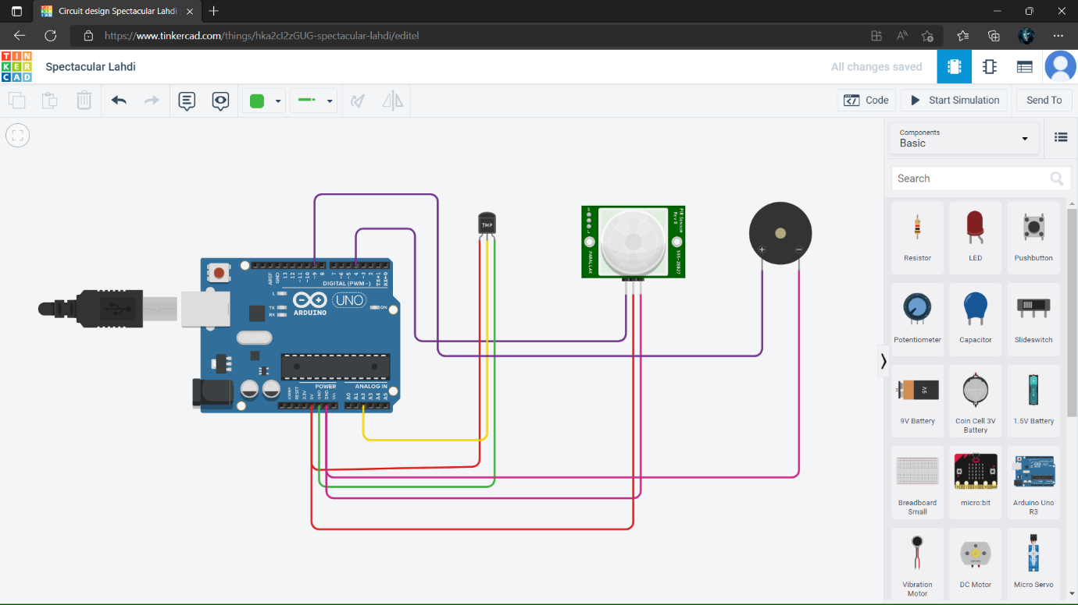

**Program :**

void setup()

{

Serial.begin(9600);

pinMode(4,INPUT);

pinMode(9,OUTPUT);

}

void loop()

{

double data=analogRead(A2);

double n=data/1024;

double volt=n*5;

double off=volt-0.5;

double temp=off*100;

Serial.print("Temperature data : ");

Serial.println(temp);

int motion=digitalRead(4);

if(temp>=60)

{

tone(9,100);

delay(1000);

}

else if(motion==1)

{

tone(9,200);

delay(1000);

}

else

{

noTone(9);

delay(1000);

}

}

